**Info pack Rocking Platform evaluation meeting:**

**An evaluation meeting about the in between results and impact of the “PBA to improve the quality of EVS between existing partners 2018”**

**by Filaretos Vourkos and Chris van Maanen, co-trainer Raluca Oancea.**

**dates: arrival 22 of September 2019 - departure 27 of September 2019**

* It is a Training so of course it is mandatory that the participants speak English. Please share this also with your participants.
* We can discuss the program with you, so we can adapt it as good as possible to the group, in here you find the general idea
* You can start selecting your participants and looking for tickets, ☺ budget according to Erasmus rules, anyway, check with me before buying ☺

The participants will be as divided below:

* Netherlands: 3 persons: 2 trainers/facilitators – 1 participant
* Germany: 3 persons
* Ukraine: 2 persons
* Georgia: 2 persons
* Romania: 3 persons – 1 trainer – 1 participant – 1 accompanying person
* Spain: 1 person
* Tunisia: 1 persons
* Slovenia: 4 persons – 2 participants – 2 accompanying persons
* Austria: 4 persons
* Armenia: 2 persons
* Moldova: 2 persons
* Jordan: 2 persons
* Hungary: 1 person
* Turkey Ebagem: 2 persons – 1 participants – 1 accompanying person
* Turkey CCYD: 4 persons
* Greece: 2 persons – 1 trainer – 1 participant
* Morocco: 2 persons
* Kosovo: 2 persons
* Macedonia: 2 persons
* Azerbaijan: 2 persons

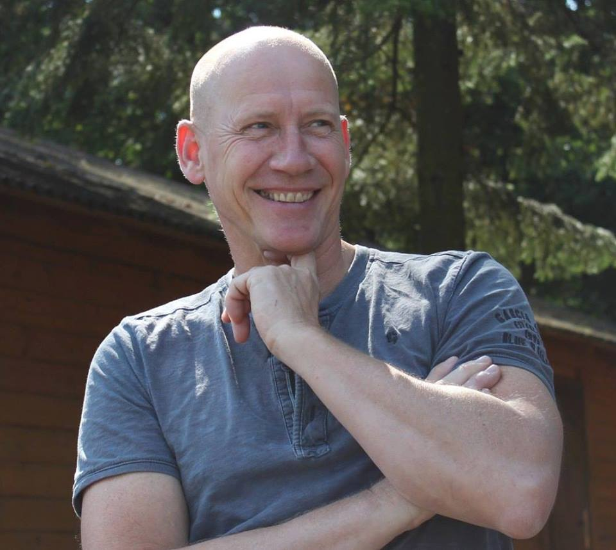Trainers: Chris van Maanen <https://www.facebook.com/chris.vanmaanen>

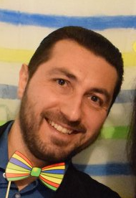& Filaretos Vourkos: <https://www.facebook.com/Filaretos>

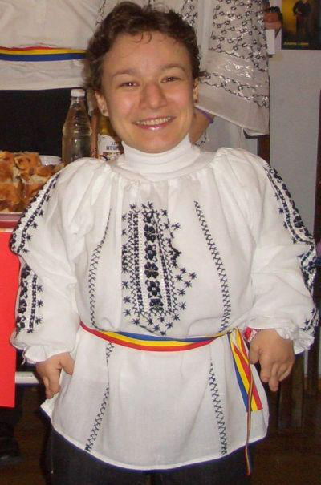& co-trainer: Raluca Oancea: <https://www.facebook.com/raluca.oancea.11>

Facebookgroup: Evaluation Meeting rocking platform: <https://www.facebook.com/groups/465860000648873/>

Information about the Venue: (as it seems now, but there can be changes)

3 six persons stone house with if needed 2 extra mattrasses

5 x fishermans cottage (6 beds)

After we have all the participants info we will make a devision of the houses.

Conference room “de Kapschuur” for the whole period

Adress: Schoterpad 1, 8314RA BANT, Netherlands. tel 0031527-261899 (there is wifi, not so well, but it works)

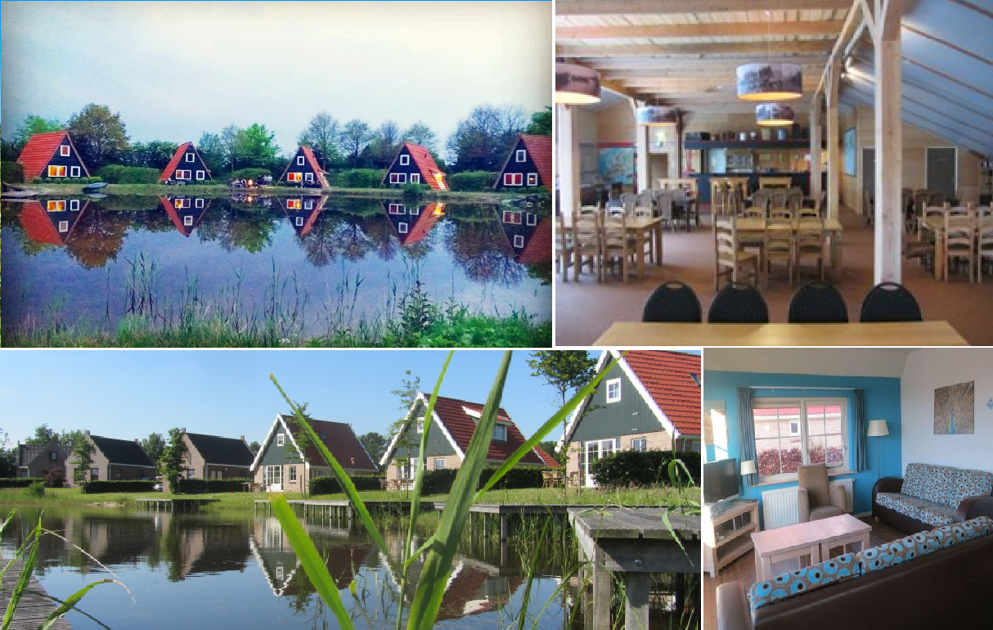

**What to prepare:**

* **There will be 2 intercultural evenings: in that evenings 8 countries will present their organisation and their country, but also will teach us something interactive, like a song or a dance or be creative! and a table with some drinks and food!**
* **Every country should prepare a small presentation about their organisation and their wishes for cooperation for the future and if there were any after effects from the PBA, and if yes which projects were set up?**
* **BRING YOUR OWN TOWELS! (BED SHEETS ARE PROVIDED)**
* **BRING SOME CLOTHES FOR CARNIVAL NIGHT!**
* **FOR THE EVENINGS WE WILL PROVIDE DRINKS FOR SUPERMARKET PRICES, SO YOU CAN PUT IT ON THE LIST AND IN THE END OF THE WEEK PAY WHAT YOU USED ☺**
* **BRING A SWIMSUIT IF YOU WANT TO ENJOY THE HOTTUB IN THE EVENINGS (or to swim in the lakes) ☺**

**TRAVEL FOR PEOPLE WHO WANT THE EASY WAY!**

* **We will arrange a bus from Schiphol (Amsterdam airport) to the venue to pick you up from the airport on 22 sept around 19.30**
* **We will arrange a bus from the venue to Schiphol (Amsterdam airport) to bring you back to the airport on 27 sept around 6.00**

**Then you need to book your tickets accordingly of course, if there are slight differences in time we will adapt the hours. (if you have many waiting hours then you can go (on your own expenses) to Amsterdam in your waiting time, it is 15 min by train directly from the airport)**

**The meeting point in the airport is in the arrival hall and is close to the burger king, now it is just a small billboard on a stick (not the cube anymore)**

**TRAVEL FOR PEOPLE WHO WANT IT THE HARD WAY ☺**

**You can fly on every available airport in the Netherlands, and from there travel by train. (Amsterdam is the most convenient, but Eindhoven will do also)**

**You can travel by train to Lelystad central station (from every airport) it will cost you 1-3 hours, from there you taken the bus to Emmeloord and from Emmeloord you take the bus to Bant, then it is about 5 km walking (if possible we will pick you up)**

**You can book the train tickets quit easy online on** [**www.ns.nl**](http://www.ns.nl) **, you can switch to English, you book 2nd class, no discount one way tickets, so one one-way ticket for coming and one for going ☺, in the Netherlands we don’t have fixed seats in the train and also you can use the train ticket all day long. So there is no fixed time. You can also go out and back in, so you can go from Schiphol to Amsterdam central and go a few hours to the city and then go back in the train and go to Lelystad. we calculate them of course for the travel costs. (from Eindhoven single trip is 21,50, from Amsterdam is 11,50, this is in your total costs for the travel.**

**As soon as you found tickets then let me know and i will help you with the rest ☺, at least try to be in time before the start and don’t leave before the end! We cannot stay longer then the program nights in the venue. You are allowed to come earlier or leave later if you want to spend some time in the Netherlands extra. Of course, then the hostel and food will be for your own costs.**

**Summary of the project:**

This is a project of Rock Solid Foundation. it is a follow up of the partnership building activity between already existing partners in EVS placings who are partly designed for working with NEET and youngsters with fewer opportunities about all the aspects of EVS.

The main objectives and goals are to improve the quality of EVS projects and to make the partnerships stronger and clearer between the different actors in the EVS placements. In parallel we will analyze and learn about the new Program, European Solidarity Corps which Guide we expect to be published by the implementation of the project.

The main goal of EVS is of course that volunteers experience a personal growth because of the EVS, especially if we are dealing with NEET and lesser opportunities! this also is the audience of most of our participating partners. from all the partners will come someone that is directly involved with EVS, in this way the direct impact on the EVS placements will be much bigger then when we ask for random participants.

During our research and with many interviews we noticed many partnering organisations have a need for further training and deepening of the existing relationships, better division of tasks and responsibilities between organisations, also cooperation, preparation and evaluation are important topics in this project.

several topics will be part of the project. Which parts should be done by SO, HO and CO and Volunteer?, What are exactly all the rules regarding EVS? which items are overlooked many times in an application but also in a real placement? how important is it to have separate mentors who can be intermediator between all the actors in the project? what do we do for aftercare of the volunteer after the EVS is ended? this and many other questions were the base for writing this partnership building activity.

All the participating organisations are already part of this active network and will select participants that are involved and responsible in their organisation for EVS. the involved countries are: Netherlands, Germany, Ukraine, Italy, Greece, Austria, Georgia, Romania, Slovenia, Tunisia, Spain, Armenia, Slovakia, Russian federation, Moldova, Belarus, Jordan, Cyprus, Hungary and Turkey.

it must be a project including the partnering countries because they are in reality having EVS placements in the Netherlands through the Rock solid Foundation.

The complete activity is build on Non-formal learning activities with a big variation on methods, also to teach the participating partners how to use them, but also the impact is proven to be better then from formal learning methods. The impact on Participants as well on organisations will be big. also the long term impact in all of Europe, because it will result in better EVS placements with better results, others will learn and copy-paste, and we hope to repeat this in the future more times with a growing network.

**Daily program will follow:**